Python data Types

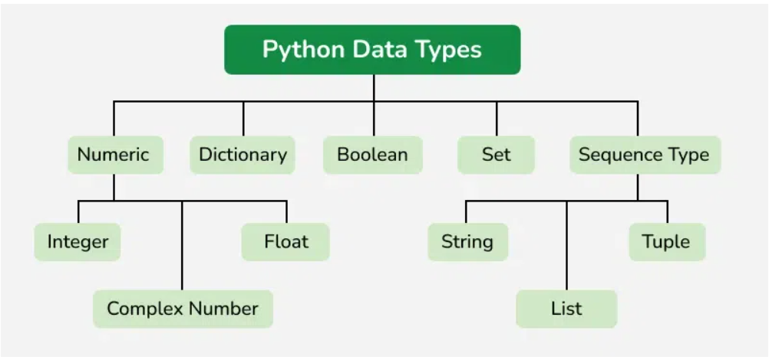

Data Type | Category
- Numeric | Int , Float , Complex
- Sequence Type | String , List , tuple
- Mapping Type | dict
- Boolean | bool
- Set Type | Set , Frozenset
- Binary Type | Byte , Bytearray, memoryview

Python Data Structures
Aspect | List | Set | String
Mutability | ✅Mutable | ✅Mutable (only immutable elements | ❌ Immutable
Data Types | Can store elements of any data type (heterogeneous) | Can store elements of any immutable type (int, str, tuple, etc.) | Stores only characters (text, Unicode)
Order | Maintains insertion order | Does not maintain order | Maintains character order
Indexing | Indexed (access via positionlist[0]) | Not indexed (no positional access) | Indexed (access via position, e.g., string[0])
Duplicates | Allows duplicates | ❌ No duplicates allowed | Characters can repeat (e.g., "hello")
Notation | [] | {}

1. Numeric
  - Integers: value is represented by int class.

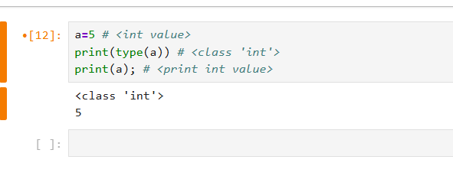
1.2 Float
Float Value is represented by float class
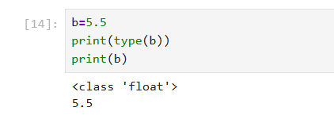

  - complex
It is represented by a complex class [ (real part) + (imaginary part)j ]
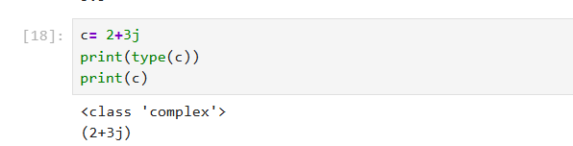

2. Sequence Type:
2.1 String
A string is an immutable, it stores characters only, but that character can be represented in letters, symbols, text.
Key Technical Properties:
Ordered: characters maintain orders in which they are inserted
Immutable: once created, values can’t be changed. Any modification creates a new string.
Indexed: Each character can be accessed by its position (starting index)
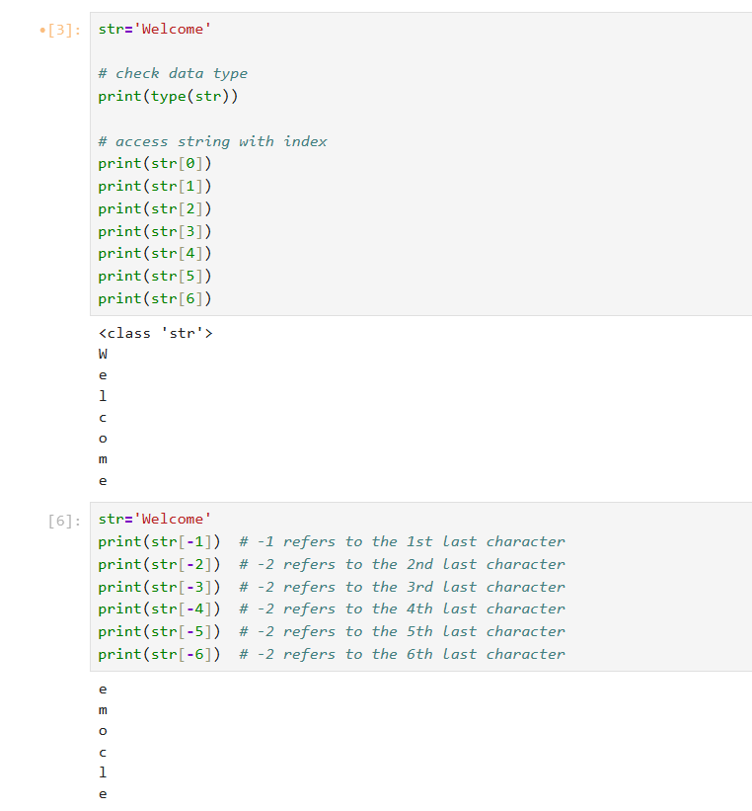

Common String Methods in Python
- Case Conversion
- capitalize() – First character uppercase, rest lowercase.
- lower() – Converts all characters to lowercase.
- upper() – Converts all characters to uppercase.
- title() – Converts to title case (first letter of each word uppercase).
- swapcase() – Swaps case of all characters. (first letter of each word Lowercase , rest lowercase or vice versa).
- casefold() – Aggressive lowercase conversion (useful for comparisons).

- Searching & Checking
- find(sub) – Returns index of first occurrence, or -1 if not found.
- index(sub) – Like find(), but raises error if not found.
- count(sub) – Counts occurrences of substring.
- startswith(prefix) – Checks if string starts with given prefix.
- endswith(suffix) – Checks if string ends with given suffix.

- Validation (Boolean checks)
- isalnum() – True if all characters are alphanumeric.
- isalpha() – True if all characters are alphabetic.
- isdigit() – True if all characters are digits.
- isnumeric() – True if all characters are numeric (includes fractions, etc.).
- isspace() – True if all characters are whitespace.
- islower(), isupper(), istitle() – Case checks.

- Modification & Formatting
- strip() – Removes leading/trailing whitespace.
- lstrip(), rstrip() – Removes whitespace from left/right.
- replace(old, new) – Replaces substring occurrences.
- split(sep) – Splits string into list by separator.
- rsplit(sep) – Splits from the right.
- splitlines() – Splits by line breaks.
- join(iterable) – Joins elements of iterable into a string.
- center(width), ljust(width), rjust(width) – Alignment methods.
- zfill(width) – Pads string with leading zeros.
- expandtabs(tabsize) – Replaces tabs with spaces.
- format(), format_map() – String formatting.

- Encoding & Utilities
- encode() – Encodes string into bytes.
- partition(sep), rpartition(sep) – Splits into 3 parts: before, separator, after.

1. Case Conversion
- capitalize() – First character uppercase, rest lowercase. Or vice-versa

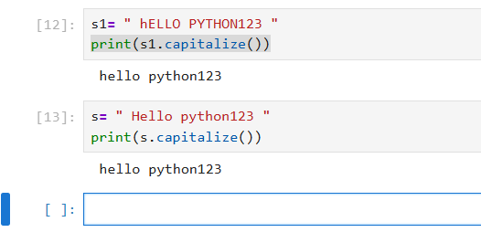
- lower() – Converts all characters to lowercase.

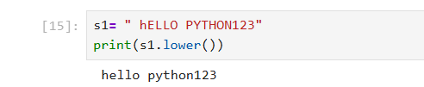

- upper() – Converts all characters to uppercase.
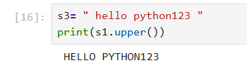

- title() – Converts to title case (first letter of each word uppercase).

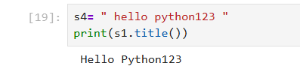

- swapcase() – Swaps case of all characters. (first letter of each word Lowercase , rest lowercase or vice versa).
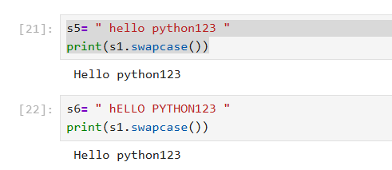
2.Searching & Checking
- find(sub) – Returns index of first occurrence, or -1 if not found.
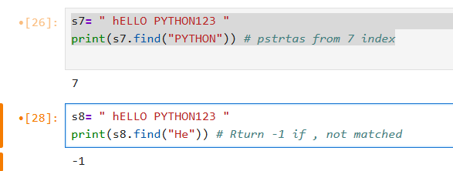

- index(sub) – Like find(), but raises error if not found.
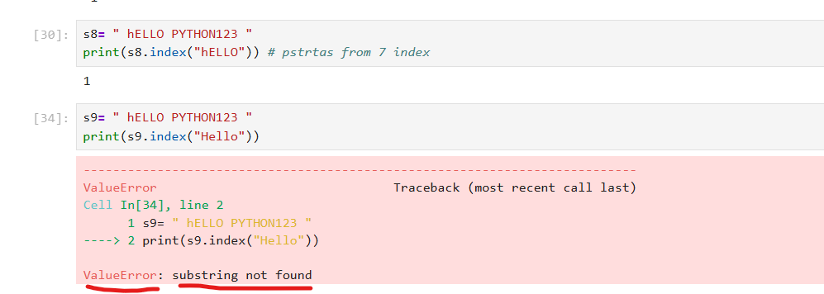

- count(sub) – Counts occurrences of substring.
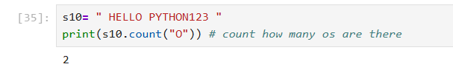
- startswith(prefix) – Checks if string starts with given prefix.
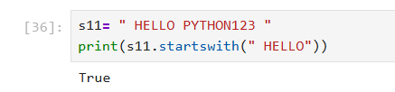

- endswith(suffix) – Checks if string ends with given suffix.
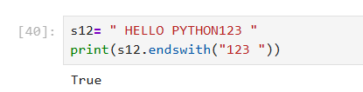

3.Validation (Boolean checks)
- isalnum() – True if all characters are alphanumeric.
- isalpha() – True if all characters are alphabetic.
- isdigit() – True if all characters are digits.
- isnumeric() – True if all characters are numeric (includes fractions, etc.).
- isspace() – True if all characters are whitespace.
- islower(), isupper(), istitle() – Case checks.
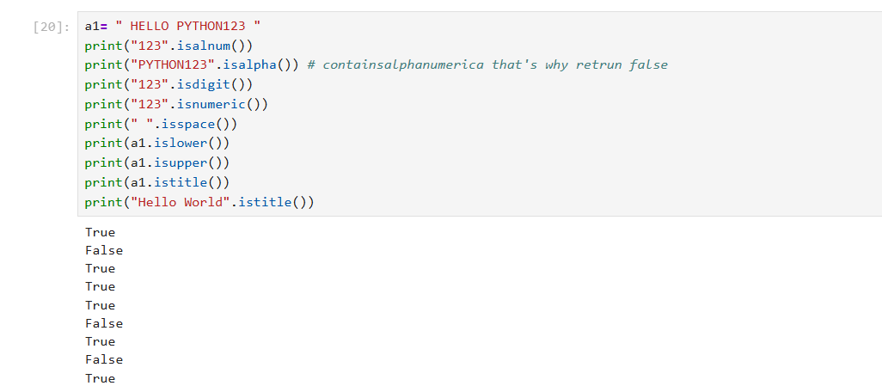

- Modification & Formatting
- strip() – Removes leading/trailing whitespace.
- lstrip(), rstrip() – Removes whitespace from left/right.
- replace(old, new) – Replaces substring occurrences.
- split(sep) – Splits string into list by separator.
- rsplit(sep) – Splits from the right.
- splitlines() – Splits by line breaks.
- join(iterable) – Joins elements of iterable into a string.
- center(width), ljust(width), rjust(width) – Alignment methods.
- zfill(width) – Pads string with leading zeros.
- expandtabs(tabsize) – Replaces tabs with spaces.
- format(), format_map() – String formatting.
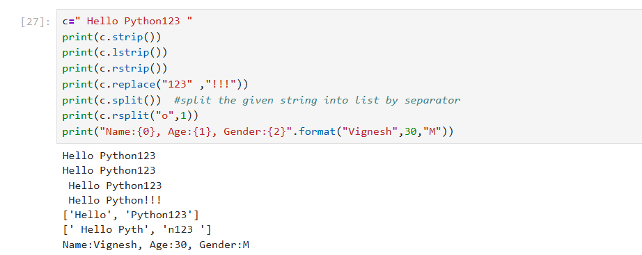
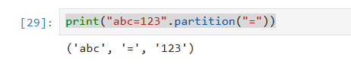

2.2 List []
List is mutable,
store heterogenous elements (can store elements of any data type)
Allow Duplicates
List can be represented in square bracket []
Key Technical Properties
Ordered: Maintain insertion order
Indexed: Elements can be accessed by its position [ strat index at 0]
Mutable: we can add, remove or change the elements, after the list is created

Common List Methods in Python
Adding Elements
- append (x) Add element at the end
- extend(iterable) Add multiple elements
- insert(i,x) insert at specific index
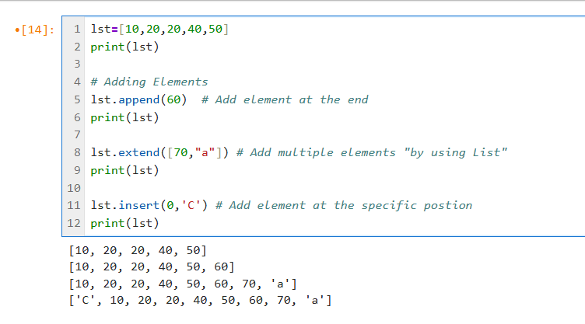

Removing Elements
- remove(“character or string”) remove 1st occurrence
- pop() remove last element
- pop(0) remve element at index 0
- clear() remove all elements

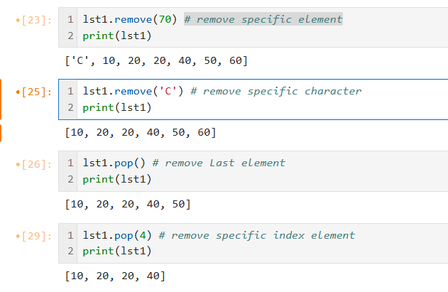

Searching and counting
- index() search 1st occurrence of element
- count() count the specific value
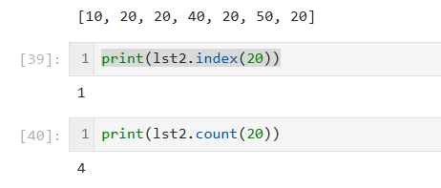
Sorting & Reversing
- sort() sort the element in ascending order
- reverse() sort the element in descending order
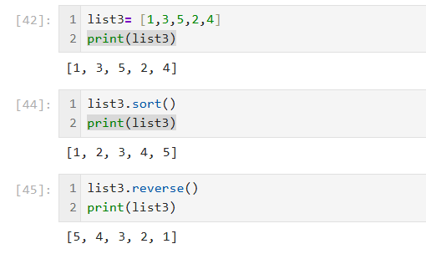

copying
- copy() copy the element
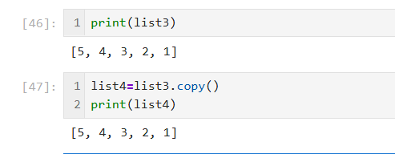

2.3 set {}
Set is mutable
Can store elements of any immutable type (int, string, tuple,etc)
No duplicates are allowed
Set can be represented by {}
Key Technical Properties
Ordered: Doesn’t Maintain insertion order
Indexed: indexing not allowed here
Mutable: we can add, remove or change the elements, but only immutable types allowed)

Adding & Removing Elements
- add (x) Add single element
- update([x,y]) Add multiple elements

Removing Elements
- remove(“character or string”) remove 1st occurrence
- pop() remove last element
- discard(0) remove element
- clear() remove all elements
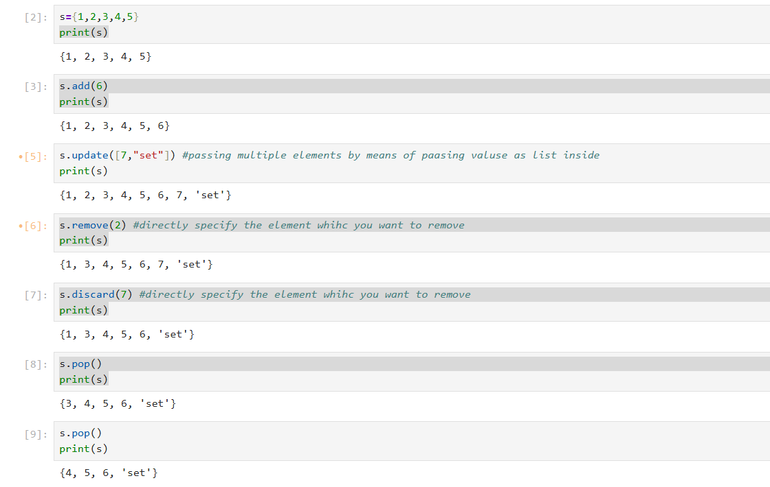
copying
- copy() copy the element
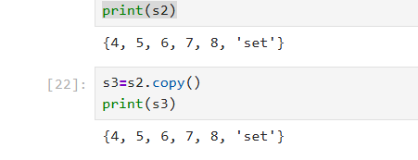

Set Operations
- union() combine both a and b set
- intersection() retrive matched element between both sets
- difference()
It returns a new set containing elements that are in the first set but not in the second (or others).
Think of it as: A − B (set subtraction).
a has {10, 20, 30}
b has {30, 40, 50}
Elements in a but not in b → {10, 20}

- symmetric_difference()
It returns a new set containing elements that are in either of the sets, but not in both.
Think of it as: (A ∪ B) − (A ∩ B)
a = {10, 20, 30}
b = {30, 40, 50}
print(a.symmetric_difference(b)) # {10, 20, 40, 50}
(A ∪ B) {10,20,30,40,50}
(A ∩ B) {30}
(A ∪ B) − (A ∩ B) = {10,20,30,40,50} - {30} = {10,20,40,50}
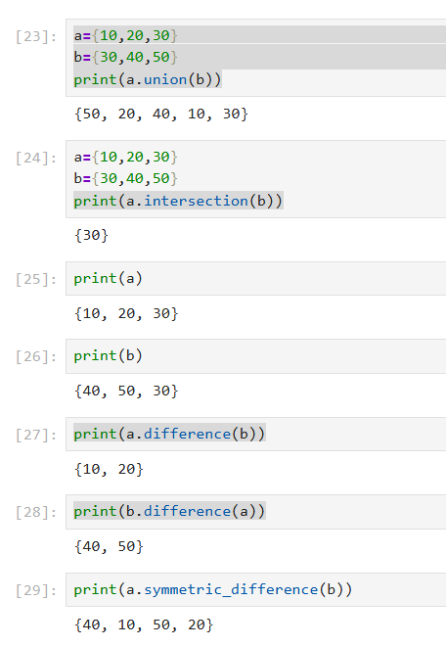

update Operations
- update() Add all the elements from b
- intersection_update() keep only common elements
- difference_update() remove elements which we passed against the comparison set
- symmetric_difference_update()
